These questions are exam level questions, so don’t worry if you can’t do them all yet – we still have a year to go!

1 Spot the Error

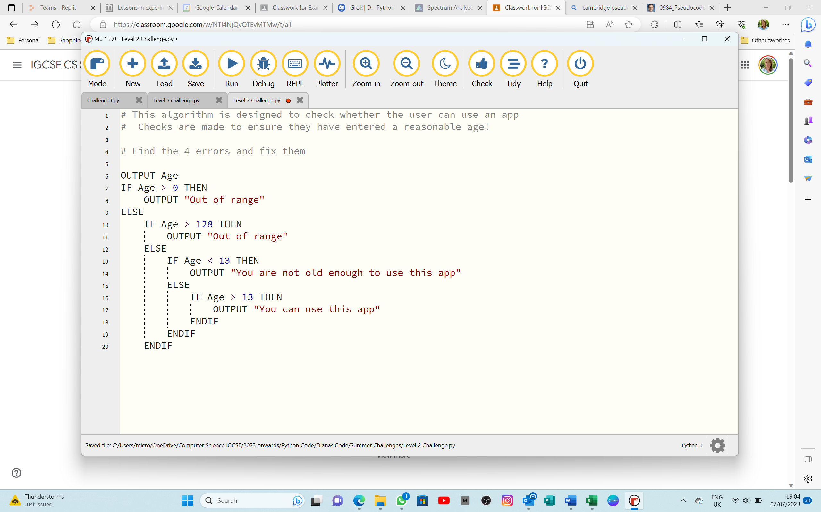

|  |
| --- |
| Error 1: |
| Correction: |
|  |
| Error 2: |
| Correction: |
|  |
| Error 3: |
| Correction: |
|  |
| Error 4: |
| Correction: |
|  |
| [4] |

b) Rewrite the pseudocode in Python using a suitable selection statement.

|  |
| --- |
|  |
|  |
|  |
|  |
|  |
|  |
|  |
|  |
| [4] |

2 Spot the Error

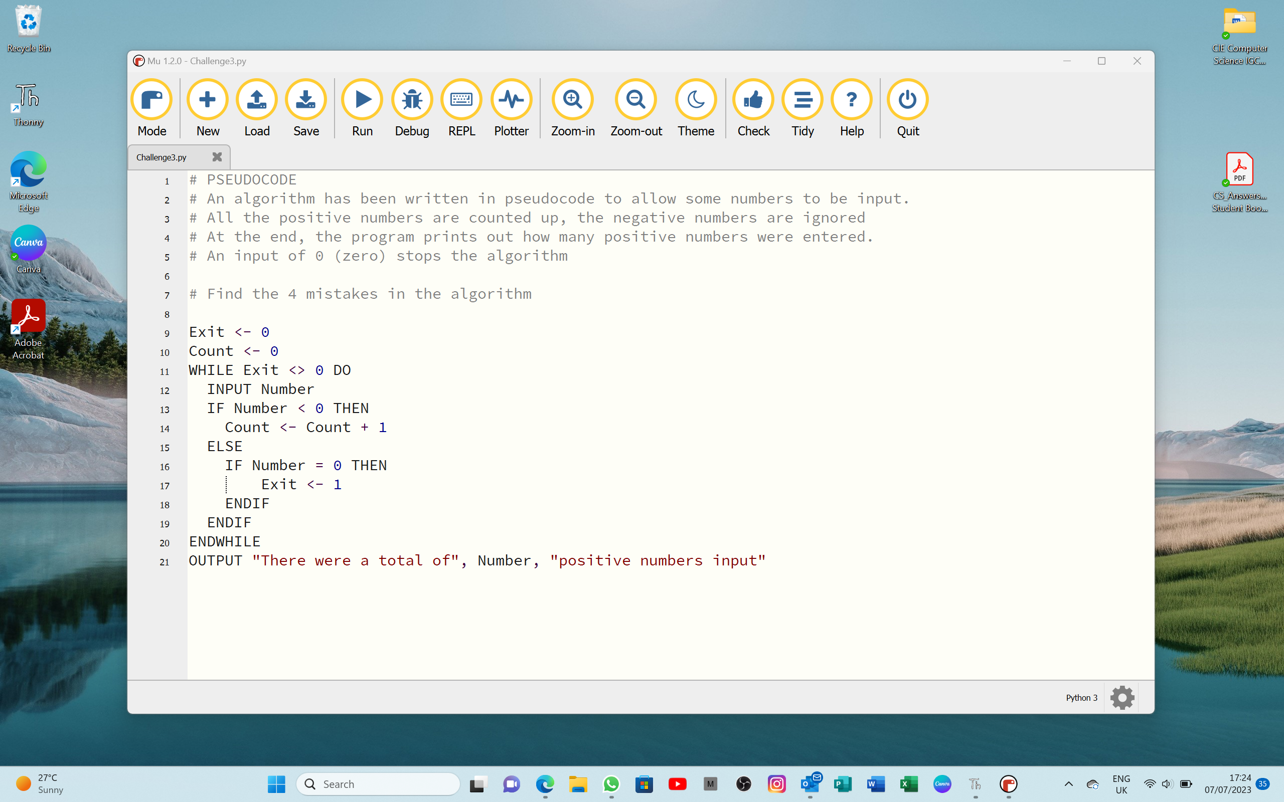

1. Identify the four errors in the pseudocode and suggest a correction for each error.

|  |
| --- |
| Error 1: |
| Correction: |
|  |
| Error 2: |
| Correction: |
|  |
| Error 3: |
| Correction: |
|  |
| Error 4: |
| Correction: |
|  |
| [4] |

1. Describe how you could change the corrected algorithm to record and output the TOTAL of all the positive numbers that have been input.

You do NOT need to rewrite the algorithm.

|  |
| --- |
|  |
|  |
|  |
|  |
|  |
|  |
|  |
|  |
| [4] |

3 The function LENGTH(Phrase) calculates the length of a string Phrase

a) Write the pseudocode statements to:

* Store the string “The beginning is the most important part” in Phrase
* Calculate and output the length of the string
* Output the string in upper case

|  |
| --- |
|  |
|  |
|  |
|  |
|  |
|  |
| [3] |

b) Write the output your pseudocode should produce.

|  |
| --- |
|  |
|  |
|  |
|  |
| [2] |

4 Find the four errors in this algorithm written in pseudocode.

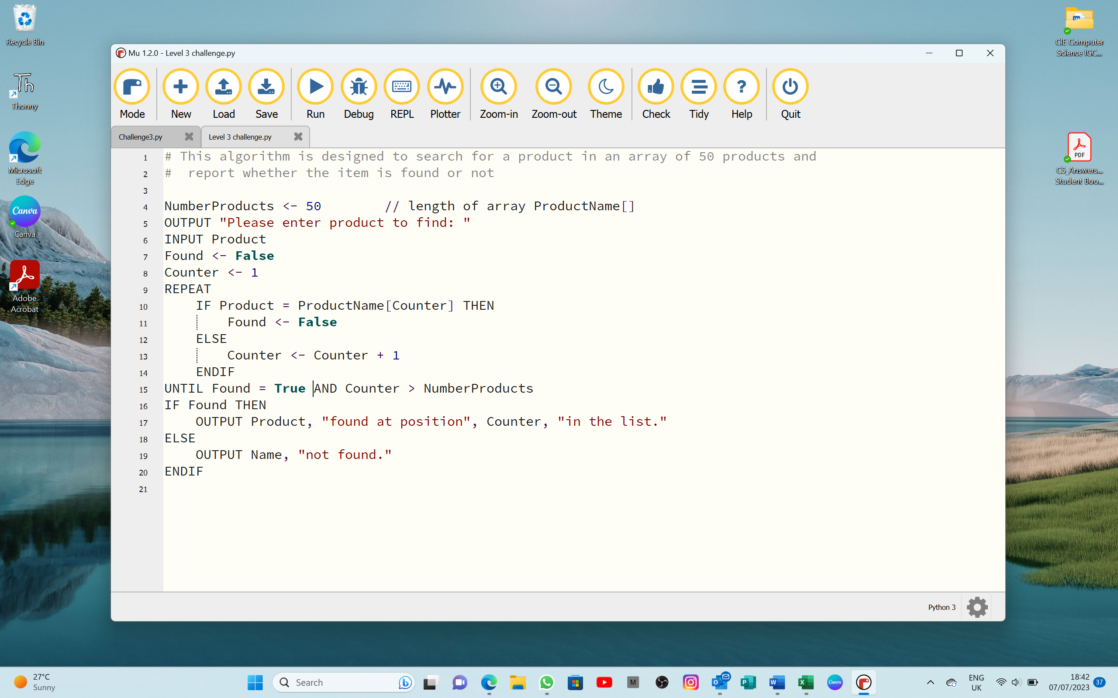

|  |
| --- |
| Error 1: |
| Correction: |
|  |
| Error 2: |
| Correction: |
|  |
| Error 3: |
| Correction: |
|  |
| Error 4: |
| Correction: |
|  |
| [4] |

5 Exam Practice

a) Write pseudocode to input 12 numbers and store them in an array.

|  |
| --- |
|  |
|  |
|  |
|  |
|  |
| [2] |

b) Change your pseudocode to use a different loop structure.

|  |
| --- |
|  |
|  |
|  |
|  |
|  |
| [2] |

c) Identify another loop structure you could have used.

|  |
| --- |
|  |
|  |
| [1] |

d) Write pseudocode to find the largest, smallest, and the average of the numbers   
you have stored.

|  |
| --- |
|  |
|  |
|  |
|  |
|  |
|  |
|  |
|  |
|  |
|  |
|  |
|  |
|  |
|  |
|  |
|  |
| [8] |